|  |
| --- |
| Predictive Health Notification  Alinity I Washzone Aspiration |
| ALINITY ci Immunoassay Analyzer  Anthony Schuler  June 25, 2018 |

**PHN - Alinity IA Washzone Aspiration Spec Sheet for Apollo**

**References**

APLM D000047921 Prognostic and Health Notification for Alinity I Washzone Aspiration

**Summary**

To implement a Prognostic Health Notification (PHN) for ALINITY i Analyzers that will detect abnormalities related to Wash Zone Aspiration.

|  |  |
| --- | --- |
| PHN Descriptor | Alinity IA Washzone Aspiration |
| PHN Experience Code / Name | CC74 PHN_Alinity_IA; PHN_Washzone 1; Aspiration P1  CC75 PHN_Alinity_IA; PHN_Washzone 1; Aspiration P2  CC76 PHN_Alinity_IA; PHN_Washzone 1; Aspiration P3  CC84 PHN_Alinity_IA; PHN_Washzone 2; Aspiration P1  CC85 PHN_Alinity_IA; PHN_Washzone 2; Aspiration P2  CC86 PHN_Alinity_IA; PHN_Washzone 2; Aspiration P3 |
| PHN KM Article Number/ Name | K27928144: PHN_Alinity_IA Washzone Aspiration |
| Service Level | FSE 2 |
| Always On Package | Always On 01DP5- 01, 02, 03, 09, 80, 83, 84, 89 |
| IDA Table(s) | IDAQOWNER.ICQ_WAM |
| IDA Table Fields | MODULESN, LOGDATE_LOCAL, WASHZONE, POSITION, EMPTYCOUNT, EMPTYTOLERANCE |
| Analysis Frequency | Daily |
| Data Required | Previous 1 day |
| Data Aggregation | None |
| Run Time Estimate | 5 seconds (7 days, 75 instruments, 271,842 rows, 32 algorithm flags) |
| Flag Criteria | For each MODULESN, WASHZONE, and POSITION combination, if (RatioOfDispensesTooLow >=0.1 and NumberOfTotalDispenses>=60) |
| Probable Failure Modes | Clogged washzone probe  Kinked or leaking washzone tubing  Insufficient vacuum pressure |
| Suppression Experience Codes | ABT3, ABT5, AB13, AB15  B71B, B712, B7TB, B7T2  A2T2, A2T3, A212, A213 |
| Applicable Work Done Codes (WDC) | BJ3* - Fluid Aspiration, Dispense and Detection; Wash Zone1 Probe; Aspiration Error / WAM  BJH* - Fluid Aspiration, Dispense and Detection; Wash Zone1 Probe; Clog / Clot / Obstruction  BJM* - Fluid Aspiration, Dispense and Detection; Wash Zone1 Probe; Leaks / Drips B73* - Fluid Aspiration, Dispense and Detection; Wash Zone2 Probe; Aspiration Error / WAM; Aligned / Adjusted / Calibrated B7H* - Fluid Aspiration, Dispense and Detection; Wash Zone 2 Probe; Clog / Clot / Obstruction B7M* - Fluid Aspiration, Dispense and Detection; Wash Zone2 Probe; Leaks / Drips |

**Data Processing Steps**

|  |  |
| --- | --- |
| Data Processing Steps | |
| 1 | Query all data from the previous day for instrument/washzone/position combination (IDA Table: IDAQOWNER.ICQ_WAM). |
| 2 | Unique washzone locations will be identified by MODULESN, WASHZONE, and POSITION. |
| 3 | For each MODULESN, WASHZONE, and POSITION combination, calculate:   * NumberOfDispensesTooCloseToThreshold= Count number of Dispenses (with EmptyCount-EmptyTolerance <=500) * NumberOfTotalDispenses=Count # of rows * RatioOfDispensesTooLow= NumberOfDispensesTooCloseToThreshold / NumberOfTotalDispenses |
| 4 | Flag any washzone location if (RatioOfDispensesTooLow >=0.1 and NumberOfTotalDispenses>=60) |

**Define Reusable Routine**

|  |  |
| --- | --- |
| **Routine Details** |  |
| Routine Source | Define Reusable Routine |
| Routine Type | Oracle Procedure |
| Run Mode | Batch |
| Routine Invoke Command | PHM_ICQ_WAM_PROC |
| Status | Disable |

|  |  |
| --- | --- |
| **Apollo Details** |  |
| Algorithm ID * | Alinity IA Washzone Aspiration - Generic |
| Algorithm Name * | Alinity IA Washzone Aspiration - Generic |
| Algorithm Description * | Generic reusable routine for Alinity IA Washzone Aspiration algorithms |
| Product Family * | Alinity IA |
| Algorithm Group * | Alinity Wash Zone |
| Functional Area | N/A |
| Algorithm Category 1 | N/A |
| Algorithm Category 2 | N/A |
| Algorithm Category 3 | N/A |
| Remaining Useful Life Value | 7 |
| Remaining Useful Life Unit | Day |
| Keep Results Num Days | 14 |
| **Routine Details** |  |
| Routine Source | Define Reusable Routine |
| Routine Type | Oracle Procedure |
| Run Mode | Batch |
| Routine Invoke Command | PHM_ICQ_WAM_PROC |
| **Parameters** |  |
| Parameter Group Name | ICQ_WAM |
| **Parameter Name** | **Parameter Values** |
| IHN_LEVEL3_DESC | IHN_LEVEL3_DESC |
| I_WZASP_THRESHOLD_NUMDISPTCTT | 500 |
| I_WZASP_THRESHOLD_NUMTOTALDISP | 60 |
| I_WZASP_THRESHOLD_POS | 1 |
| I_WZASP_THRESHOLD_RATIODISPTL | 0.1 |
| I_WZASP_THRESHOLD_WZ | 1 |
| THRESHOLDS_COUNT | 1 |
| THRESHOLD_DESCRIPTION | THRESHOLD_DESCRIPTION |

**APPENDIX 1:** CC74 PHN_Alinity_IA; PHN_Washzone 1; Aspiration P1

**Algorithm Code**

SELECT

inner.MODULESN

FROM

(SELECT

W.MODULESN,

COUNT(W.EMPTYCOUNT) AS NUMTOTALDISP,

(SUM(CASE WHEN (W.EMPTYCOUNT - W.EMPTYTOLERANCE) <= 500 THEN 1 ELSE 0 END)) / (COUNT(W.EMPTYCOUNT)) AS RATIODISPTL

FROM

IDAQOWNER.ICQ_WAM W

WHERE

W.LOGDATE_LOCAL >= TRUNC(SYSDATE) - 1

AND W.LOGDATE_LOCAL < TRUNC(SYSDATE)

AND W.WASHZONE = 1

AND W.POSITION = 1

GROUP BY

W.MODULESN) inner

WHERE

inner.RATIODISPTL >= 0.1

and inner.NUMTOTALDISP >= 60

**Apollo Algorithm Details**

(* is Mandatory)

|  |  |
| --- | --- |
| **Apollo Details** |  |
| Algorithm ID * | Alinity IA Washzone1 P1 Aspiration |
| Algorithm Name * | Alinity IA Washzone1 P1 Aspiration |
| Algorithm Description * | Monitors the Wash Zones for degrading performance |
| Product Family * | Alinity IA |
| Algorithm Group * | Alinity Wash Zone |
| Functional Area | N/A |
| Algorithm Category 1 | N/A |
| Algorithm Category 2 | N/A |
| Algorithm Category 3 | N/A |
| Remaining Useful Life Value | 7 |
| Remaining Useful Life Unit | Day |
| Keep Results Num Days | 14 |
| **Routine Details** |  |
| Routine Source | Use Reusable Routine |
| Reusable Routines | Alinity IA Washzone Aspiration - Generic |
| Run Mode | Batch |
| Status | Enable |
| **ODS Routine Details** |  |
| ODS Routine Name | PHM_ODS_ICQ_WAM_PROC |
| **Prognostic Health Notification Details** |  |
| PHN Code | PHN_Alinity_IA_CC74 |
| Issue Description (Use Algorithm Name) |  |
| Experience Code | CC74 |
| **Knowledge Management DB Articles** |  |
| KM Article ID | K27928144 |
| KM Article | PHN_Alinity_IA: Wash Zone Aspiration |
| **Parameters** |  |
| Parameter Group Name | ICQ_WAM |
| **Parameter Name** | **Parameter Values** |
| IHN_LEVEL3_DESC | Alinity IA Washzone1 P1 Aspiration |
| I_WZASP_THRESHOLD_NUMDISPTCTT | 500 |
| I_WZASP_THRESHOLD_NUMTOTALDISP | 60 |
| I_WZASP_THRESHOLD_POS | 1 |
| I_WZASP_THRESHOLD_RATIODISPTL | 0.1 |
| I_WZASP_THRESHOLD_WZ | 1 |
| THRESHOLDS_COUNT | 1 |
| THRESHOLDS_DESCRIPTION | Alinity IA Washzone1 P1 Aspiration |
| **Chart Details** |  |
| Chart Title | Alinity IA Washzone1 P1 Aspiration |
| Chart Type | Line |
| Chart Threshold Parameter | ICQ_WAM-THRESHOLDS_COUNT |
| Group ID | Group 7 |
| Chart X Axis Name | Date |
| Chart Y Axis Name | Threshold Count |

**APPENDIX 2:** CC75 PHN_Alinity_IA; PHN_Washzone 1; Aspiration P2

**Algorithm Code**

SELECT

inner.MODULESN

FROM

(SELECT

W.MODULESN,

COUNT(W.EMPTYCOUNT) AS NUMTOTALDISP,

(SUM(CASE WHEN (W.EMPTYCOUNT - W.EMPTYTOLERANCE) <= 500 THEN 1 ELSE 0 END)) / (COUNT(W.EMPTYCOUNT)) AS RATIODISPTL

FROM

IDAQOWNER.ICQ_WAM W

WHERE

W.LOGDATE_LOCAL >= TRUNC(SYSDATE) - 1

AND W.LOGDATE_LOCAL < TRUNC(SYSDATE)

AND W.WASHZONE = 1

AND W.POSITION = 2

GROUP BY

W.MODULESN) inner

WHERE

inner.RATIODISPTL >= 0.1

and inner.NUMTOTALDISP >= 60

**Apollo Algorithm Details**

(* is Mandatory)

|  |  |
| --- | --- |
| **Apollo Details** |  |
| Algorithm ID * | Alinity IA Washzone1 P2 Aspiration |
| Algorithm Name * | Alinity IA Washzone1 P2 Aspiration |
| Algorithm Description * | Monitors the Wash Zones for degrading performance |
| Product Family * | Alinity IA |
| Algorithm Group * | Alinity Wash Zone |
| Functional Area | N/A |
| Algorithm Category 1 | N/A |
| Algorithm Category 2 | N/A |
| Algorithm Category 3 | N/A |
| Remaining Useful Life Value | 7 |
| Remaining Useful Life Unit | Day |
| Keep Results Num Days | 14 |
| **Routine Details** |  |
| Routine Source | Use Reusable Routine |
| Reusable Routines | Alinity IA Washzone Aspiration - Generic |
| Run Mode | Batch |
| Status | Enable |
| **ODS Routine Details** |  |
| ODS Routine Name | PHM_ODS_ICQ_WAM_PROC |
| **Prognostic Health Notification Details** |  |
| PHN Code | PHN_Alinity_IA_CC75 |
| Issue Description (Use Algorithm Name) |  |
| Experience Code | CC75 |
| **Knowledge Management DB Articles** |  |
| KM Article ID | K27928144 |
| KM Article | PHN_Alinity_IA: Wash Zone Aspiration |
| **Parameters** |  |
| Parameter Group Name | ICQ_WAM |
| **Parameter Name** | **Parameter Values** |
| IHN_LEVEL3_DESC | Alinity IA Washzone1 P2 Aspiration |
| I_WZASP_THRESHOLD_NUMDISPTCTT | 500 |
| I_WZASP_THRESHOLD_NUMTOTALDISP | 60 |
| I_WZASP_THRESHOLD_POS | 2 |
| I_WZASP_THRESHOLD_RATIODISPTL | 0.1 |
| I_WZASP_THRESHOLD_WZ | 1 |
| THRESHOLDS_COUNT | 1 |
| THRESHOLDS_DESCRIPTION | Alinity IA Washzone1 P2 Aspiration |
| **Chart Details** |  |
| Chart Title | Alinity IA Washzone1 P2 Aspiration |
| Chart Type | Line |
| Chart Threshold Parameter | ICQ_WAM-THRESHOLDS_COUNT |
| Group ID | Group 7 |
| Chart X Axis Name | Date |
| Chart Y Axis Name | Threshold Count |

**APPENDIX 3:** CC76 PHN_Alinity_IA; PHN_Washzone 1; Aspiration P3

**Algorithm Code**

SELECT

inner.MODULESN

FROM

(SELECT

W.MODULESN,

COUNT(W.EMPTYCOUNT) AS NUMTOTALDISP,

(SUM(CASE WHEN (W.EMPTYCOUNT - W.EMPTYTOLERANCE) <= 500 THEN 1 ELSE 0 END)) / (COUNT(W.EMPTYCOUNT)) AS RATIODISPTL

FROM

IDAQOWNER.ICQ_WAM W

WHERE

W.LOGDATE_LOCAL >= TRUNC(SYSDATE) - 1

AND W.LOGDATE_LOCAL < TRUNC(SYSDATE)

AND W.WASHZONE = 1

AND W.POSITION = 3

GROUP BY

W.MODULESN) inner

WHERE

inner.RATIODISPTL >= 0.1

and inner.NUMTOTALDISP >= 60

**Apollo Algorithm Details**

(* is Mandatory)

|  |  |
| --- | --- |
| **Apollo Details** |  |
| Algorithm ID * | Alinity IA Washzone1 P3 Aspiration |
| Algorithm Name * | Alinity IA Washzone1 P3 Aspiration |
| Algorithm Description * | Monitors the Wash Zones for degrading performance |
| Product Family * | Alinity IA |
| Algorithm Group * | Alinity Wash Zone |
| Functional Area | N/A |
| Algorithm Category 1 | N/A |
| Algorithm Category 2 | N/A |
| Algorithm Category 3 | N/A |
| Remaining Useful Life Value | 7 |
| Remaining Useful Life Unit | Day |
| Keep Results Num Days | 14 |
| **Routine Details** |  |
| Routine Source | Use Reusable Routine |
| Reusable Routines | Alinity IA Washzone Aspiration - Generic |
| Run Mode | Batch |
| Status | Enable |
| **ODS Routine Details** |  |
| ODS Routine Name | PHM_ODS_ICQ_WAM_PROC |
| **Prognostic Health Notification Details** |  |
| PHN Code | PHN_Alinity_IA_CC76 |
| Issue Description (Use Algorithm Name) |  |
| Experience Code | CC76 |
| **Knowledge Management DB Articles** |  |
| KM Article ID | K27928144 |
| KM Article | PHN_Alinity_IA: Wash Zone Aspiration |
| **Parameters** |  |
| Parameter Group Name | ICQ_WAM |
| **Parameter Name** | **Parameter Values** |
| IHN_LEVEL3_DESC | Alinity IA Washzone1 P3 Aspiration |
| I_WZASP_THRESHOLD_NUMDISPTCTT | 500 |
| I_WZASP_THRESHOLD_NUMTOTALDISP | 60 |
| I_WZASP_THRESHOLD_POS | 3 |
| I_WZASP_THRESHOLD_RATIODISPTL | 0.1 |
| I_WZASP_THRESHOLD_WZ | 1 |
| THRESHOLDS_COUNT | 1 |
| THRESHOLDS_DESCRIPTION | Alinity IA Washzone1 P3 Aspiration |
| **Chart Details** |  |
| Chart Title | Alinity IA Washzone1 P3 Aspiration |
| Chart Type | Line |
| Chart Threshold Parameter | ICQ_WAM-THRESHOLDS_COUNT |
| Group ID | Group 7 |
| Chart X Axis Name | Date |
| Chart Y Axis Name | Threshold Count |

**APPENDIX 4:** CC84 PHN_Alinity_IA; PHN_Washzone 2; Aspiration P1

**Algorithm Code**

SELECT

inner.MODULESN

FROM

(SELECT

W.MODULESN,

COUNT(W.EMPTYCOUNT) AS NUMTOTALDISP,

(SUM(CASE WHEN (W.EMPTYCOUNT - W.EMPTYTOLERANCE) <= 500 THEN 1 ELSE 0 END)) / (COUNT(W.EMPTYCOUNT)) AS RATIODISPTL

FROM

IDAQOWNER.ICQ_WAM W

WHERE

W.LOGDATE_LOCAL >= TRUNC(SYSDATE) - 1

AND W.LOGDATE_LOCAL < TRUNC(SYSDATE)

AND W.WASHZONE = 2

AND W.POSITION = 1

GROUP BY

W.MODULESN) inner

WHERE

inner.RATIODISPTL >= 0.1

and inner.NUMTOTALDISP >= 60

**Apollo Algorithm Details**

(* is Mandatory)

|  |  |
| --- | --- |
| **Apollo Details** |  |
| Algorithm ID * | Alinity IA Washzone2 P1 Aspiration |
| Algorithm Name * | Alinity IA Washzone2 P1 Aspiration |
| Algorithm Description * | Monitors the Wash Zones for degrading performance |
| Product Family * | Alinity IA |
| Algorithm Group * | Alinity Wash Zone |
| Functional Area | N/A |
| Algorithm Category 1 | N/A |
| Algorithm Category 2 | N/A |
| Algorithm Category 3 | N/A |
| Remaining Useful Life Value | 7 |
| Remaining Useful Life Unit | Day |
| Keep Results Num Days | 14 |
| **Routine Details** |  |
| Routine Source | Use Reusable Routine |
| Reusable Routines | Alinity IA Washzone Aspiration - Generic |
| Run Mode | Batch |
| Status | Enable |
| **ODS Routine Details** |  |
| ODS Routine Name | PHM_ODS_ICQ_WAM_PROC |
| **Prognostic Health Notification Details** |  |
| PHN Code | PHN_Alinity_IA_CC84 |
| Issue Description (Use Algorithm Name) |  |
| Experience Code | CC84 |
| **Knowledge Management DB Articles** |  |
| KM Article ID | K27928144 |
| KM Article | PHN_Alinity_IA: Wash Zone Aspiration |
| **Parameters** |  |
| Parameter Group Name | ICQ_WAM |
| **Parameter Name** | **Parameter Values** |
| IHN_LEVEL3_DESC | Alinity IA Washzone2 P1 Aspiration |
| I_WZASP_THRESHOLD_NUMDISPTCTT | 500 |
| I_WZASP_THRESHOLD_NUMTOTALDISP | 60 |
| I_WZASP_THRESHOLD_POS | 1 |
| I_WZASP_THRESHOLD_RATIODISPTL | 0.1 |
| I_WZASP_THRESHOLD_WZ | 2 |
| THRESHOLDS_COUNT | 1 |
| THRESHOLDS_DESCRIPTION | Alinity IA Washzone2 P1 Aspiration |
| **Chart Details** |  |
| Chart Title | Alinity IA Washzone2 P1 Aspiration |
| Chart Type | Line |
| Chart Threshold Parameter | ICQ_WAM-THRESHOLDS_COUNT |
| Group ID | Group 7 |
| Chart X Axis Name | Date |
| Chart Y Axis Name | Threshold Count |

**APPENDIX 5:** CC85 PHN_Alinity_IA; PHN_Washzone 2; Aspiration P2

**Algorithm Code**

SELECT

inner.MODULESN

FROM

(SELECT

W.MODULESN,

COUNT(W.EMPTYCOUNT) AS NUMTOTALDISP,

(SUM(CASE WHEN (W.EMPTYCOUNT - W.EMPTYTOLERANCE) <= 500 THEN 1 ELSE 0 END)) / (COUNT(W.EMPTYCOUNT)) AS RATIODISPTL

FROM

IDAQOWNER.ICQ_WAM W

WHERE

W.LOGDATE_LOCAL >= TRUNC(SYSDATE) - 1

AND W.LOGDATE_LOCAL < TRUNC(SYSDATE)

AND W.WASHZONE = 2

AND W.POSITION = 2

GROUP BY

W.MODULESN) inner

WHERE

inner.RATIODISPTL >= 0.1

and inner.NUMTOTALDISP >= 60

**Apollo Algorithm Details**

(* is Mandatory)

|  |  |
| --- | --- |
| **Apollo Details** |  |
| Algorithm ID * | Alinity IA Washzone2 P2 Aspiration |
| Algorithm Name * | Alinity IA Washzone2 P2 Aspiration |
| Algorithm Description * | Monitors the Wash Zones for degrading performance |
| Product Family * | Alinity IA |
| Algorithm Group * | Alinity Wash Zone |
| Functional Area | N/A |
| Algorithm Category 1 | N/A |
| Algorithm Category 2 | N/A |
| Algorithm Category 3 | N/A |
| Remaining Useful Life Value | 7 |
| Remaining Useful Life Unit | Day |
| Keep Results Num Days | 14 |
| **Routine Details** |  |
| Routine Source | Use Reusable Routine |
| Reusable Routines | Alinity IA Washzone Aspiration - Generic |
| Run Mode | Batch |
| Status | Enable |
| **ODS Routine Details** |  |
| ODS Routine Name | PHM_ODS_ICQ_WAM_PROC |
| **Prognostic Health Notification Details** |  |
| PHN Code | PHN_Alinity_IA_CC85 |
| Issue Description (Use Algorithm Name) |  |
| Experience Code | CC85 |
| **Knowledge Management DB Articles** |  |
| KM Article ID | K27928144 |
| KM Article | PHN_Alinity_IA: Wash Zone Aspiration |
| **Parameters** |  |
| **Parameters** |  |
| Parameter Group Name | ICQ_WAM |
| **Parameter Name** | **Parameter Values** |
| IHN_LEVEL3_DESC | Alinity IA Washzone2 P2 Aspiration |
| I_WZASP_THRESHOLD_NUMDISPTCTT | 500 |
| I_WZASP_THRESHOLD_NUMTOTALDISP | 60 |
| I_WZASP_THRESHOLD_POS | 2 |
| I_WZASP_THRESHOLD_RATIODISPTL | 0.1 |
| I_WZASP_THRESHOLD_WZ | 2 |
| THRESHOLDS_COUNT | 1 |
| THRESHOLDS_DESCRIPTION | Alinity IA Washzone2 P2 Aspiration |
| **Chart Details** |  |
| Chart Title | Alinity IA Washzone2 P2 Aspiration |
| Chart Type | Line |
| Chart Threshold Parameter | ICQ_WAM-THRESHOLDS_COUNT |
| Group ID | Group 7 |
| Chart X Axis Name | Date |
| Chart Y Axis Name | Threshold Count |

**APPENDIX 6:** CC86 PHN_Alinity_IA; PHN_Washzone 2; Aspiration P3

**Algorithm Code**

SELECT

inner.MODULESN

FROM

(SELECT

W.MODULESN,

COUNT(W.EMPTYCOUNT) AS NUMTOTALDISP,

(SUM(CASE WHEN (W.EMPTYCOUNT - W.EMPTYTOLERANCE) <= 500 THEN 1 ELSE 0 END)) / (COUNT(W.EMPTYCOUNT)) AS RATIODISPTL

FROM

IDAQOWNER.ICQ_WAM W

WHERE

W.LOGDATE_LOCAL >= TRUNC(SYSDATE) - 1

AND W.LOGDATE_LOCAL < TRUNC(SYSDATE)

AND W.WASHZONE = 2

AND W.POSITION = 3

GROUP BY

W.MODULESN) inner

WHERE

inner.RATIODISPTL >= 0.1

and inner.NUMTOTALDISP >= 60

**Apollo Algorithm Details**

(* is Mandatory)

|  |  |
| --- | --- |
| **Apollo Details** |  |
| Algorithm ID * | Alinity IA Washzone2 P3 Aspiration |
| Algorithm Name * | Alinity IA Washzone2 P3 Aspiration |
| Algorithm Description * | Monitors the Wash Zones for degrading performance |
| Product Family * | Alinity IA |
| Algorithm Group * | Alinity Wash Zone |
| Functional Area | N/A |
| Algorithm Category 1 | N/A |
| Algorithm Category 2 | N/A |
| Algorithm Category 3 | N/A |
| Remaining Useful Life Value | 7 |
| Remaining Useful Life Unit | Day |
| Keep Results Num Days | 14 |
| **Routine Details** |  |
| Routine Source | Use Reusable Routine |
| Reusable Routines | Alinity IA Washzone Aspiration - Generic |
| Run Mode | Batch |
| Status | Enable |
| **ODS Routine Details** |  |
| ODS Routine Name | PHM_ODS_ICQ_WAM_PROC |
| **Prognostic Health Notification Details** |  |
| PHN Code | PHN_Alinity_IA_CC86 |
| Issue Description (Use Algorithm Name) | Alinity IA Washzone2 P3 Aspiration |
| Experience Code | CC86 |
| **Knowledge Management DB Articles** |  |
| KM Article ID | K27928144 |
| KM Article | PHN_Alinity_IA: Wash Zone Aspiration |
| **Parameters** |  |
| Parameter Group Name | ICQ_WAM |
| **Parameter Name** | **Parameter Values** |
| IHN_LEVEL3_DESC | Alinity IA Washzone2 P3 Aspiration |
| I_WZASP_THRESHOLD_NUMDISPTCTT | 500 |
| I_WZASP_THRESHOLD_NUMTOTALDISP | 60 |
| I_WZASP_THRESHOLD_POS | 3 |
| I_WZASP_THRESHOLD_RATIODISPTL | 0.1 |
| I_WZASP_THRESHOLD_WZ | 2 |
| THRESHOLDS_COUNT | 1 |
| THRESHOLDS_DESCRIPTION | Alinity IA Washzone2 P3 Aspiration |
| **Chart Details** |  |
| Chart Title | Alinity IA Washzone2 P3 Aspiration |
| Chart Type | Line |
| Chart Threshold Parameter | ICQ_WAM-THRESHOLDS_COUNT |
| Group ID | Group 7 |
| Chart X Axis Name | Date |
| Chart Y Axis Name | Threshold Count |

**APPENDIX 7:** Algorithm Understanding Check – Algorithm Developer to Prognostic Health Monitoring (PHM) Specialist Transition

**Data Set Description**

The data set for this understanding check was retrieved from the ICQOWNER.ODR_WAMICQ table within the BSQD1I database. Data was collected for all instruments between October 1, 2017 and October 7, 2017, inclusive. Data collection was limited to the MODULESN, LOGDATE, WASHZONE, POSITION, EMPTYCOUNT, and EMPTYTOLERANCE fields.

**Data Set Retrieval**

The following SQL code was used to retrieve the data set:

SELECT

W.MODULESN,

W.LOGDATE,

W.WASHZONE,

W.POSITION,

W.EMPTYCOUNT,

W.EMPTYTOLERANCE

FROM

ICQOWNER.ODR_WAMICQ W

WHERE

TRUNC(W.LOGDATE) >= TO_DATE('10/01/2017 12:00:00 AM', 'mm/dd/yyyy hh:mi:ss am')

AND TRUNC(W.LOGDATE) < TO_DATE('10/08/2017 12:00:00 AM', 'mm/dd/yyyy hh:mi:ss am')

**Algorithm Developer Analysis**

The following processing steps were used by the Algorithm Developer to analyze the data set and flag algorithm violations:

1. Querry data from BSQD1i from ODR_WAMICQ table from Oct/01/2017 to Oct/07/2017
2. For each row:
   1. Truncate LogDate by day
   2. Calculate EMT=EmptyCount – EmptyTolerance
   3. Create a EMTBelow500 column to be set to 1 if EMT<=500, 0 otherwise
3. Summarize for Each ModleSN, Washone, and Position the # of Dispenses per Day and # of EMTBelow500 per day=1
4. Calculate for summarized table the ratio of (# Of EMTBelow500 per day)/(#Of Dispenses per day)

Create a flag Column if ratio >=10% & #Of Dispenses per day >=60

**PHM Specialist Analysis**

The following SQL code was used by the PHM Specialist to analyze the data set and flag algorithm violations:

SELECT

inner.*

FROM

(SELECT

W.MODULESN,

TRUNC(W.LOGDATE) AS DAY,

W.WASHZONE,

W.POSITION,

SUM(CASE WHEN (W.EMPTYCOUNT - W.EMPTYTOLERANCE) <= 500 THEN 1 ELSE 0 END) AS NUMDISPTCTT,

COUNT(W.EMPTYCOUNT) AS NUMTOTALDISP,

(SUM(CASE WHEN (W.EMPTYCOUNT - W.EMPTYTOLERANCE) <= 500 THEN 1 ELSE 0 END)) / (COUNT(W.EMPTYCOUNT)) AS RATIODISPTL

FROM

ICQOWNER.ODR_WAMICQ W

WHERE

TRUNC(W.LOGDATE) >= TO_DATE('10/01/2017 12:00:00 AM', 'mm/dd/yyyy hh:mi:ss am')

AND TRUNC(W.LOGDATE) < TO_DATE('10/08/2017 12:00:00 AM', 'mm/dd/yyyy hh:mi:ss am')

GROUP BY

W.MODULESN,

TRUNC(W.LOGDATE),

W.WASHZONE,

W.POSITION) inner

WHERE

inner.RATIODISPTL >= 0.1

and inner.NUMTOTALDISP >= 60

**Algorithm Developer Analysis Output**

The following 32 instrument (MODULESN), day (Day), washzone (WASHZONE), and position (POSITION) combinations were identified as violating the algorithm by the Algorithm Developer:

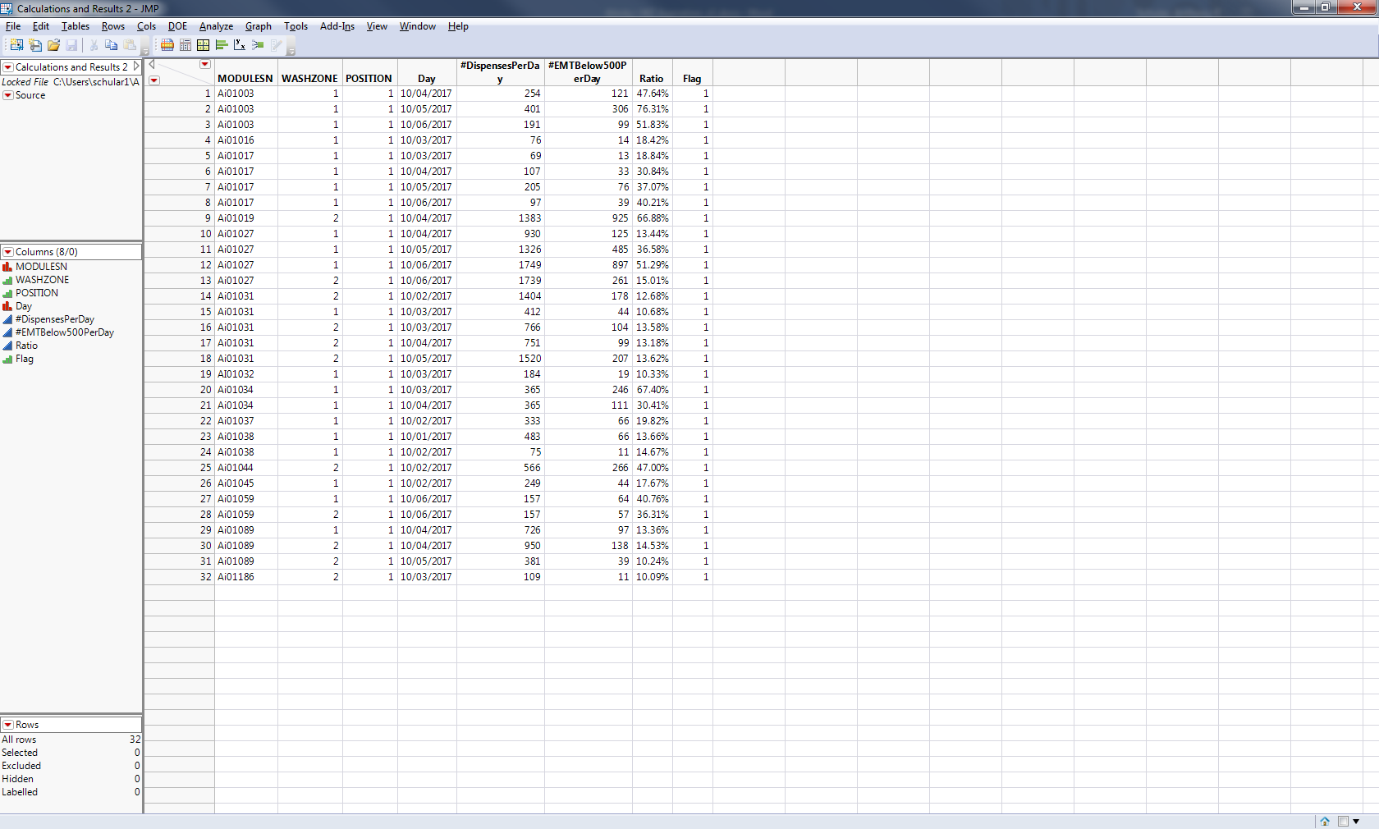

**PHM Specialist Analysis Output**

The following 32 instrument (MODULESN), day (DAY), washzone (WASHZONE), and position (POSITION) combinations were identified as violating the algorithm by the PHM Specialist:

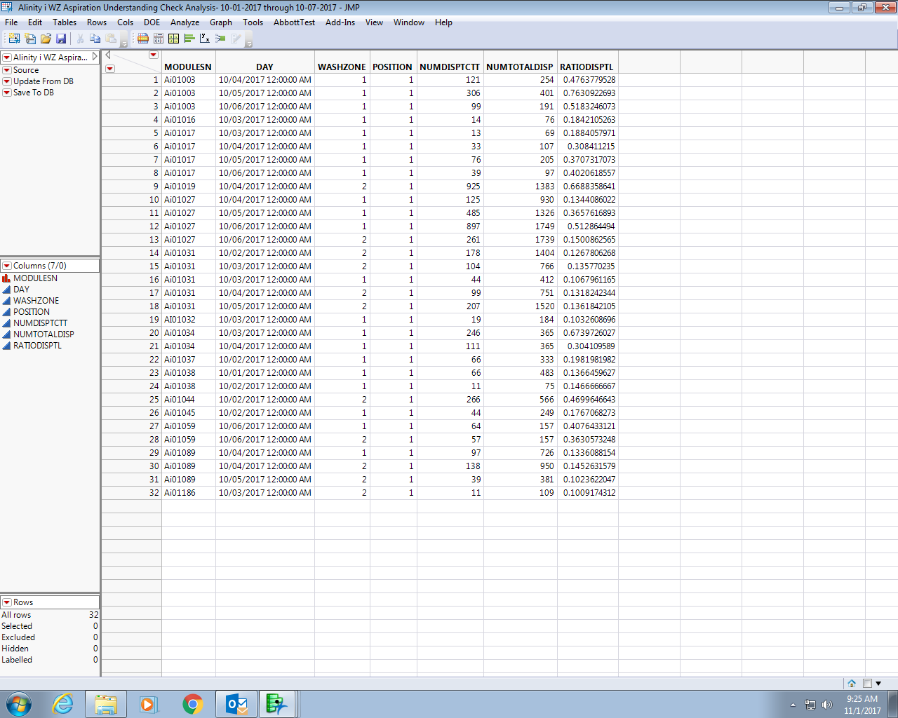

**Algorithm Developer & PHM Specialist Output Comparison**

|  |  |  |  |
| --- | --- | --- | --- |
| Total # of Unique Instrument-Part-Days Tested | Total # of Algorithm Developer Flags | Total # of PHM Specialist Flags | Total # of Matched Flags (Algorithm Developer vs. PHM Specialist) |
| **1,560** | **32** | **32** | **32** |

**Understanding Check Summary**

Based on the outputs from both the Algorithm Developer and PHN Specialist, the PHN Specialist’s understanding of the delivered algorithm is confirmed. Both the Algorithm Developer and PHN Specialist analyzed the same data set and got the same results. In particular, the MODULESN, Day/DAY, WASHZONE, and POSITION fields matched for all 32 instrument-part-day (MODULESN- WASHZONE/POSITION-Day/DAY) combinations. This means that both the Algorithm Developer and PHN Specialist flagged the same 32 algorithm violations within the given data set. Furthermore, there were no mismatches between the output from the Algorithm Developer and the output from the PHM Specialist.

**APPENDIX 8:** Algorithm Transition to Apollo – PHM Specialist to Apollo Developer

**Data Set Description**

The data set for this transition was retrieved from the IDAQOWNER.ICQ_ITDATA table within the DABBTO database. Data was collected for all available instruments between June, 12 2018 and June 13, 2018, inclusive.

**PHM Specialist Analysis Output**

The following 19 instrument-days (MODULESN-DAY) were identified as violating the algorithm by the PHM Specialist:

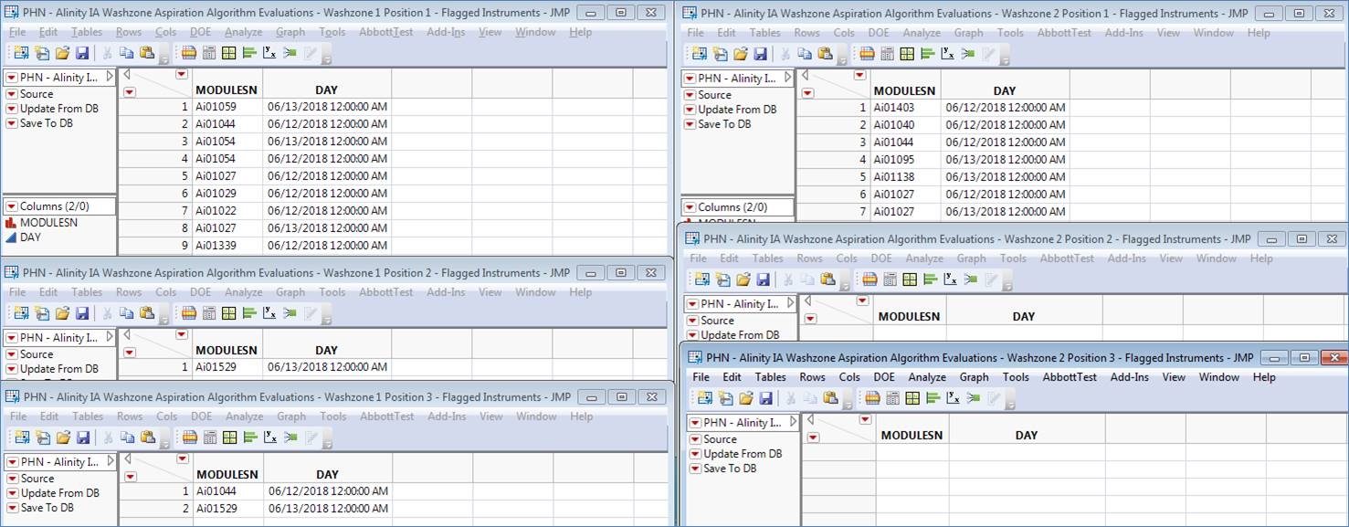

**Apollo Developer Analysis Output**

The following 9 instrument-days (SN-FLAG_DATE) were identified as violating the algorithm by the Apollo Developer (note that where the Apollo Developer and PHM Specialist don’t match is because the instruments do not exist in the Apollo environment, and therefore have no data to run the algorithm against):

Washzone 1 Position 1:

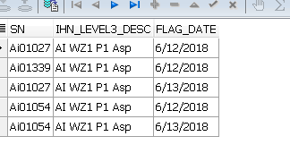

Washzone 1 Position 2:

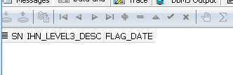

Washzone 1 Position 3:

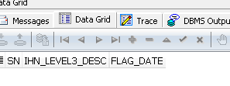

Washzone 2 Position 1:

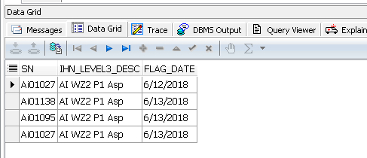

Washzone 2 Position 2:

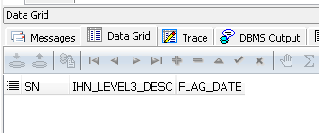

Washzone 2 Position 3:



**Algorithm Transition Summary**

Based on the outputs from both the Apollo Developer and PHM Specialist, the Apollo Developer’s understanding of the delivered algorithm is confirmed. Both the Apollo Developer and PHM Specialist analyzed the same data set and got the same results (with the exception of the instruments not in Apollo as mentioned previously). In particular, the MODULESN/SN and DAY/FLAG_DATE fields matched by washzone and position. This means that both the Apollo Developer and PHM Specialist flagged the same algorithm violations within the given data set.